

**Mathematics Specialist**

**Unit 4**

**2017**

**TEST 5**

**SOLUTIONS**

**Student name:** _______________________  **Teacher name:** _______________________

**Time allowed for this task: 40 *minutes***, in class, under test conditions

Calculator-Assumed

**Materials required:**

Standard items: Pens (blue/black preferred), pencils (including coloured), sharpener, correction fluid/tape, eraser, ruler, highlighters, SCSA Formula Sheet.

Classpad Calculator and Scientific Calculator.

Special items: Drawing instruments, templates

**Marks available: *39 marks***

**Task weighting: 8%**

**Question 1. (7 marks)**

(a) A particle undergoing simple harmonic motion with a period of 5 seconds is observed to move in a straight line, oscillating 3.6 m either side of a central position. Determine the speed of the particle when it is 3 m from the central position. (3 marks)

|  |
| --- |
| **Solution** |
|  |
| **Specific behaviours** |
| ✓ determines  ✓ substitutes into velocity equation  ✓ evaluates speed |

(b) Another particle moving in a straight line experiences an acceleration of ms-2, where is the position of the particle at time $t$ seconds.

Given that when $x=1$, the particle had a velocity of 2 ms-1, determine the velocity of the particle when $x=2$. (4 marks)

|  |
| --- |
| **Solution** |
| $$\frac{1}{2}v^{2}=\int{x+2.5}dx \\ v^{2}=2\left(\frac{x^{2}}{2}+2.5x\right)+c \\ x=1, v=2⇒c=-2 \\ x=2⇒v^{2}=2\left(\frac{2^{2}}{2}+2.5(2)\right)-2⇒v=±2\sqrt{3}$$ |
| **Specific behaviours** |
| ✓ uses appropriate form of acceleration  ✓ integrates  ✓ evaluates constant  ✓ states all possible values of v |

Question 2. (8 marks)

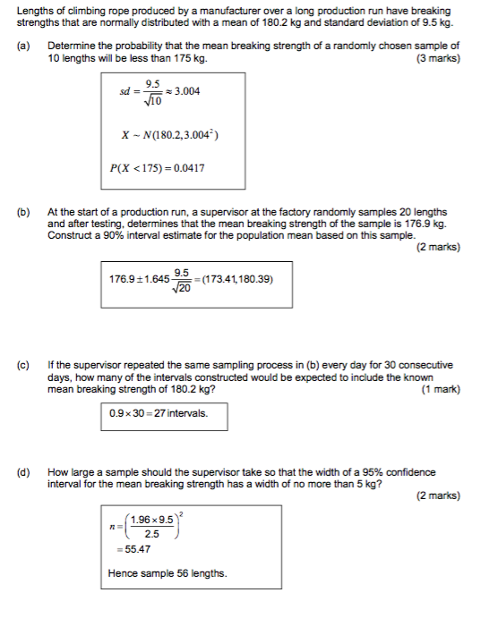

Question 3. (12 marks)

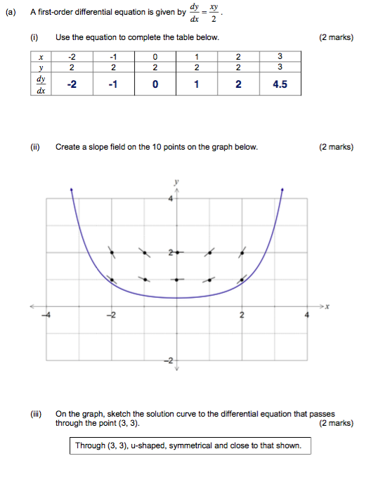

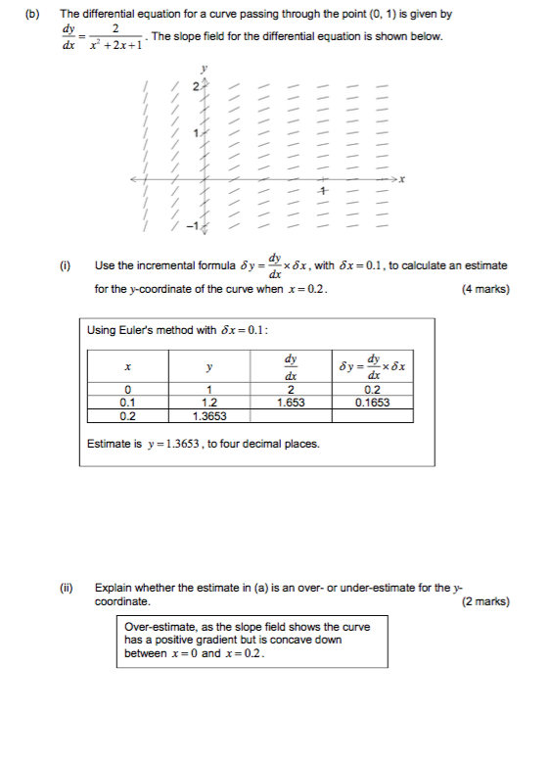

Question 4. (12 marks)

